**HTML (up to version 4.01)**

**Hyper Text Markup Language**

* Used to mainly create webpages (and other kinds of documents) viewable in a web browsers

**HTML Editor**

* Software tool to create and modify HTML docs
* Two types:
  + Basic Text Editor
    - Write simple text
    - Basic file handling (ie. New, Open. Copy, Paste, etc.) and other features (ie. Font size, etc.)
    - Examples of Basic Text Editor (Emacs, Nano, Notepad, SciTE, TextMate, UltraEdit, vi, Vim, etc.)
  + Source Text Editor
    - Syntax highlighting
    - Templates
    - Toolbars and Keyboard Shortcuts
    - Insertion of Common HTML elements
    - Wizards
    - Tooltip prompts
    - Auto-completion
    - Examples of some of the **Source Text Editor** are : Alleycode HTML Editor, Aptana, BlueFish, Coda, Eclipse with the Web Tools Platform, EditPlus, HTML-Kit, Notepad++, NetBeans IDE, PHPEdit, Scintilla, TextMate, TextPad etc.
  + WYSIWYG Editors (what you see is what you get)
    - Provides an interface which looks like how the page will look like in a web browser
    - Offers all the features in a source editor
    - Examples are : Dreamweaver, Amaya, CoffeeCup HTML Editor, KompoZer, Microsoft Visual Web Developer Express, Microsoft Publisher, Opera Dragonfly Quanta Plus, SeaMonkey Composer, TinyMce etc.

**Components of an HTML page**

1. DOCTYPE

* Declares the version of an HTML Document.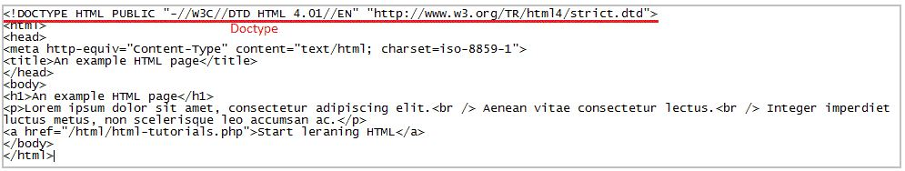

1. HTML Elements and Tags

* May contain content (text, image, video, etc.), attributes and other elements in an HTML document.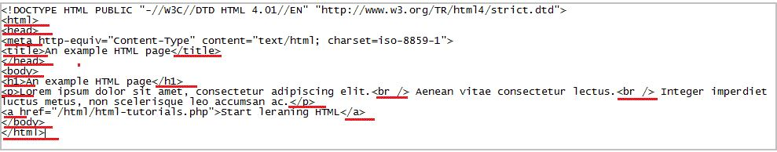

1. HTML Attributes

* Sets either style or layout or content related information for an HTML element.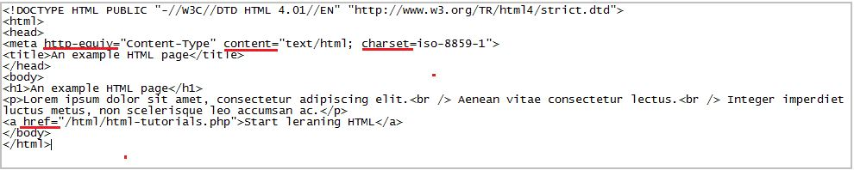

1. HTML Comments

* Excludes a part of the code from being displayed in a browser.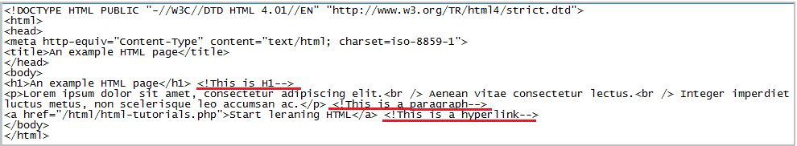

1. HTML Frames

* Contains other HTML pages.
* Users can view several HTML pages in the same browser window.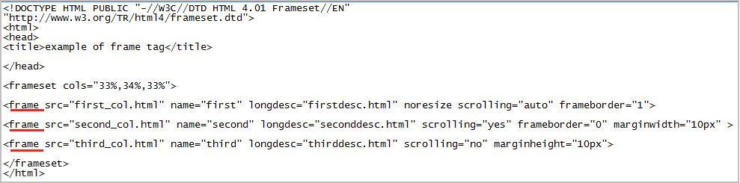

**HTML Block level and Inline Elements**

**Block level Elements**

* Can appear in the body of an HTML page
* Can contain another block level as well as inline elements
* Begin on new lines
* Create larger structures
* Examples are: p , (h1, h2, h3, h4, h5, h6), ol , ul , pre , address , blockquote , dl , div , fieldset , form , hr , noscript , table

**Inline level Elements**

* Can appear within the body of an HTML page
* Can contain data and other inline elements
* Do not begin on new lines
* Create shorter structures
* Examples are:
  + b, big, I, small, tt
  + abbr, acronym, cite, code, dfn, em, kbd, strong, samp, var
  + a, bdo, br, img, map, object, q, script, span, sub, sup
  + button, input, label, select, textarea

**List of HTML 4.01 elements**

* a: Anchor
* abbr: Abbreviation
* acronym: Acronym
* address: Address
* applet: Applet
* b: Bold
* base: Base URL
* base: Base Font Size
* bdo: Bi-Directional Override
* big: Big
* blockquote: Blockquote
* body: Body
* br: Break
* button: Button
* caption: Table caption
* center: Center align
* cite: Citation
* code: Computer code
* col: Table column
* dd: Definition description
* del: Deleted text
* dfn: Instance definition
* dir: Directory list
* dl: Definition list
* dt: Definition term
* em: Emphasis
* fieldset: Form control Group
* font: Font
* form: Form
* frame: Frame
* frameset: Frameset
* h1: Header 1
* h2: Header 2
* h3: Header 3
* h4: Header 4
* h5: Header 5
* h6: Header 6
* head: Head
* hr: Horizontal Rule
* HTML: HTML document root
* i: Italics
* iframe: Iframe
* img: Image
* input: Input
* ins: Inserted text
* isindex: Single line prompt
* kbd: Keyboard Input
* label: Label
* legend: Legend
* li: List Item
* link: Media Independent link
* map: Client-side image map
* menu: menu list
* meta: Meta information
* noframes: No Frames
* noscript: No script
* object: Object
* ol: Ordered list
* optgroup: Option group
* option: Select an option
* p: Paragraph
* param: Named property value
* preL Preformatted text
* q: Quotation
* s: Strike through text style
* samp: Sample program output, Scripts
* script: Script statements
* select: Option Selector
* small: Small text
* span: Generic style or language container
* strike: Strike through text
* strong: Strong emphasis
* style: Style info
* sub: Subscript
* sup: Superscript
* table: Table
* tbody: Table body
* td: Table data
* textarea: Textarea or a form
* tfoot: Table foot
* th: Table header cell
* thead: Table header
* title: Title of document
* tr: Table row
* tt: Tele type
* u: Underline text style
* ul: Unordered list
* var: An instance of a variable or program argument

**HTML Attribute**

* an associated property of an HTML element.
* used to extend the capability of an HTML element.
* usually have values and are written after a “=” after the name of the attribute.
* **Attribute value pair** is placed before the last “>” of an HTML start tag.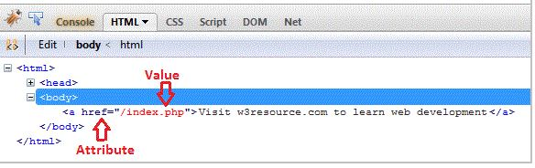
* Multiple Attribute value pair separated by space(white space) can also be used in an element. 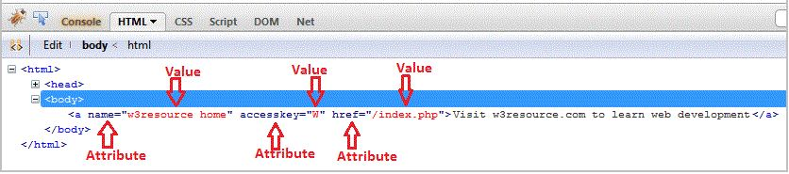
* In HTML 4.01, values of the attributes may be wrapped by double quotes, which is not mandatory. But in XHTML it is mandatory.
* HTML attributes are case sensitive while its values are not.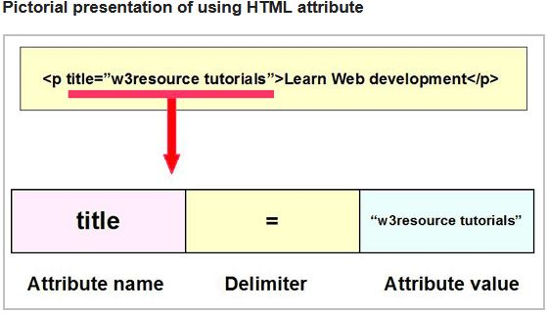

**HTML 4.01 Valid attributes**

1. abbr

* specifies the abbreviation for a table header cell.
* supports td and th elements.
* type of value is text.
* No default value.

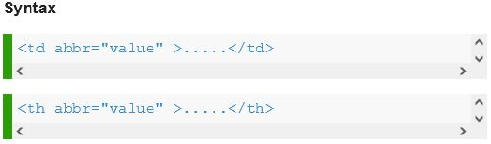

1. accept-charset

* specifies the supported character sets for a form.
* type of value is a valid character set (for example ISO-8859-1).
* No default value.
* 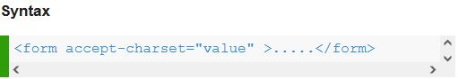

1. accept

* specifies the supported MIME types (content type) of a form or input element.
* specifies a filter for what file types the user can pick from the file input dialog box.
* can only be used with <input type="file">.
* Supports input elements.
* type of value is a valid Content Type (for example image/gif) or a comma-separated content types.
* No default value.

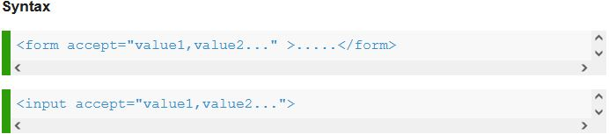

1. accesskey

* specifies the shortcut key for accessibility/to activate/focus an element
* supports Global attributes.
* type of value must be a single character (an alphabet).
* No default value.

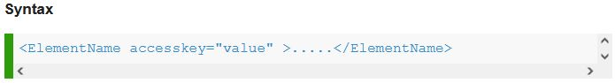

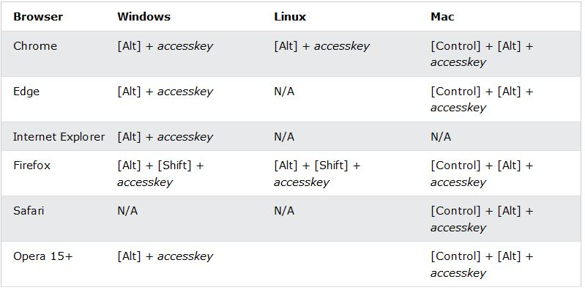

1. action

* Specifies where to send the form-data when a form is submitted (for example a PHP script which handles the form data).
* Type of value is an URL (containing a form processing script).
* No default value.

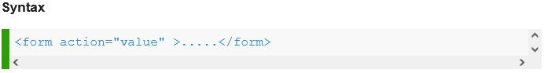

1. align

* Specifies the alignment according to surrounding elements. Use CSS instead.

1. alt

* Specifies an alternate text when the original element fails to display.
* Supports area, img and input elements.
* Type of value is text (containing a short description of the adjacent content).
* No default value.

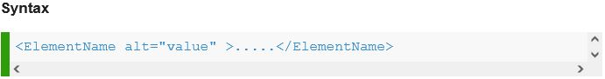

1. async

* specifies that the script will be executed asynchronously as soon as it is available.
* Is a Boolean attribute
* only for external scripts (and should only be used if the src attribute is present).
* Supports script element.

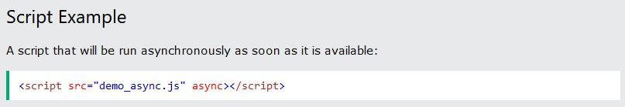

1. autocomplete

* specifies whether a form or an input field should have autocomplete on or off.
* allows the browser to predict the value. When a user starts to type in a field, the browser should display options to fill in the field, based on earlier typed values.
* Supports form and input elements.
* works with the following <input> types: text, search, url, tel, email, password, datepickers, range, and color.

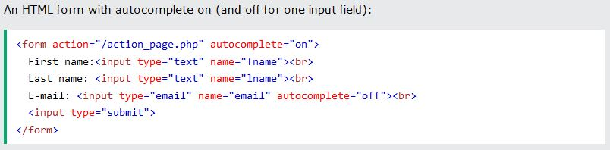

1. autofocus

* a Boolean attribute
* specifies that the element should automatically get focus when the page loads.
* Supports button, input, select and textarea elements.
* No values needed.

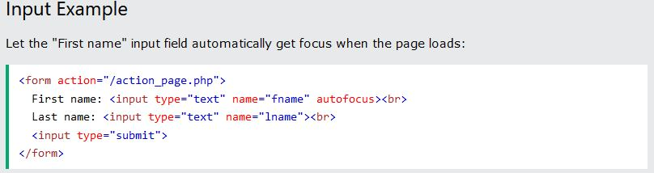

1. autoplay

* a Boolean attribute
* Specifies that the audio/video will start playing as soon as it is ready.
* Supports audio and video elements.
* No values needed.

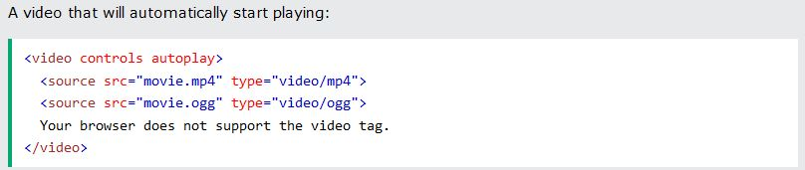

1. bgcolor

* Specifies the background color of an element. Use CSS instead.

1. border

* Specifies the width of the border of an element. Use CSS instead.

1. cellpadding

* to set a spacing within table cells.
* Supports table element.
* Type of value is pixel, percent or multilength/relative length.
* No default value.

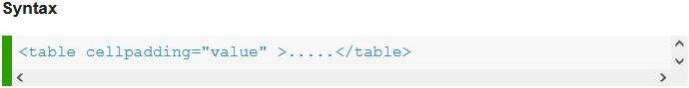

1. cellspacing

* to set a spacing between table cells.
* Supports table element.
* Type of value is pixel, percent or multilength/relative length.
* No default value.

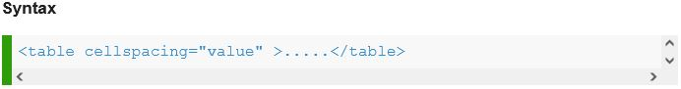

1. char

* defines the axis of alignment for a block of text.
* supports col, colgroup, tbody, td, tfoot, th, thead, tr element.
* Type of value is a character.
* Default value is a period/decimal point.
* Not supported in HTML5

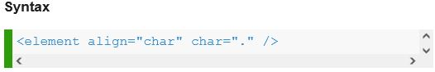

1. charset

* defines the character encoding style of a given linked resource.
* supports meta (specifies the character encoding for the HTML document) and script (specifies the character encoding used in an external script file) elements.
* HTML5 encourages the use of UTF-8 charset which covers almost all of the characters and symbols.

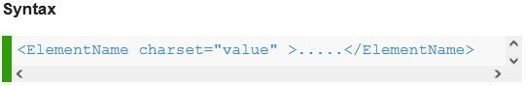

1. checked

* a Boolean attribute.
* defines whether a checkbox or a radio button is checked.
* supports the input element.
* type of value is checked. If set, then selects the checkbox or radio button by default.
* no need to input value.

1. cite

* specifies a URL to a document that explains the quote, or why the text was inserted/changed.
* supports blockquote, del, ins, q elements.
* type of value is URL.

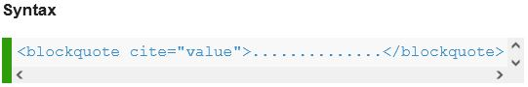

1. class

* specifies one or more classnames for an element.
* used to point to a class in a style sheet.
* can also be used by a JavaScript (via the HTML DOM) to make changes to HTML elements with a specified class.
* Global attribute
* Syntax: <ElementName class=”user-defined class”>Text</ElementName>

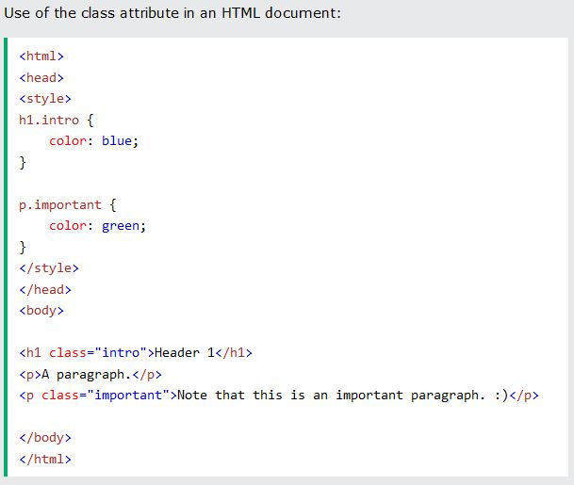

1. classid

* specify the URL of the implementation for an embedded object.
* supports object element.
* Type of value is a URL.
* no default value.

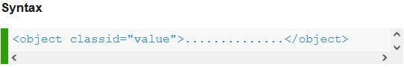

1. codebase

* defines the base URL for a class ID, data file, or archive specified with the object tag.
* supports object element.
* Type of value is a URL.
* no default value.

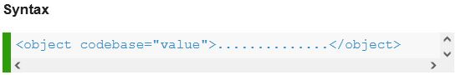

1. codetype

* defines the content-type for the code embedded by the object tag.
* supports object element.
* type of value is content type.
* no default value.

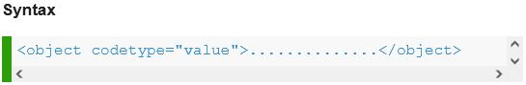

1. cols

* specifies the visible width of a text area.
* defines the number of columns in a text area or frame set.
* size of a textarea can also be set by the CSS height and width properties.
* supports textarea element and is a required attribute for textarea
* type of value is relative length if used with frameset and a number to specify number of columns if used with textarea.

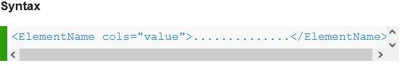

1. colspan

* defines the number of columns a table cell should span.
* supports td and th elements.
* type of value is a number.

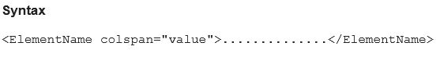

1. content

* specifies the related information for a given meta key.
* supports meta element.
* gives the value associated with the http-equiv or name attribute.
* type of value is a character data or text.

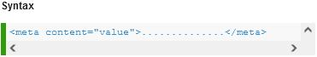

1. contenteditable

* specifies whether the content of an element is editable or not.
* when not set on an element, the element will inherit it from its parent.
* Global attribute.

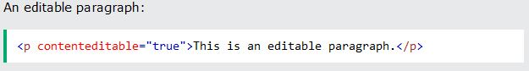

1. contextmenu

* specifies a context menu for an element. The context menu appears when a user right-clicks on the element.
* Global attribute.
* only works on Firefox browser.

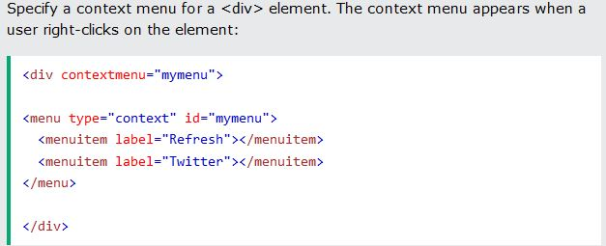

1. controls

* a Boolean attribute.
* specifies that audio/video controls should be displayed.
* includes Play, Pause, Seeking, volume, full screen toggle (for video), Captions/Subtitles (for video) and Track (for video).
* supports audio and video elements.

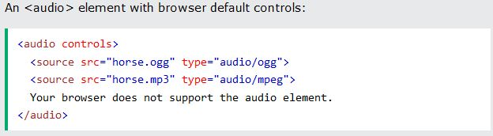

1. coords

* specifies the coordinates of an area in an image map.
* used together with the shape attribute to specify the size, shape, and placement of an area.
* supports area element.
* coordinates of the top-left corner of an area are 0,0.

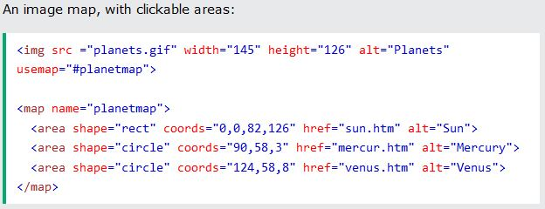

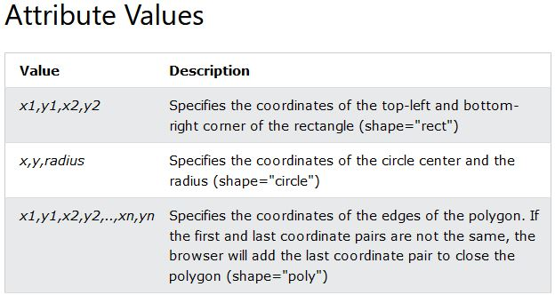

1. data

* specifies the URL of the resource to be used by the object.
* supports object element.
* type of value is a URL.

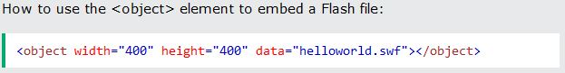

1. data-*

* used to store custom data private to the page or application.
* ability to embed custom data attributes on all HTML elements.
* global attribute.
* attribute name should not contain any uppercase letters, and must be at least one character long after the prefix "data-“.

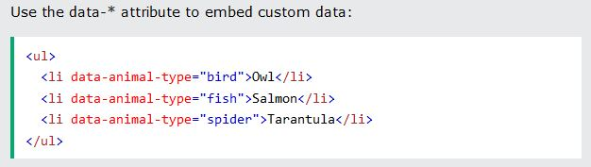

1. datetime

* specifies the date and time when the text was deleted/inserted.
* supports del, ins, time elements.

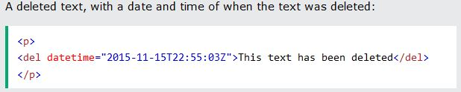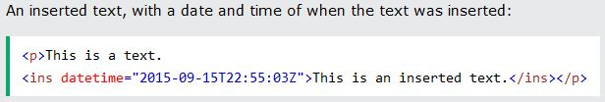

1. default

* Boolean attribute.
* specifies that the track is to be enabled if the user's preferences do not indicate that another track would be more appropriate.
* supports track element.

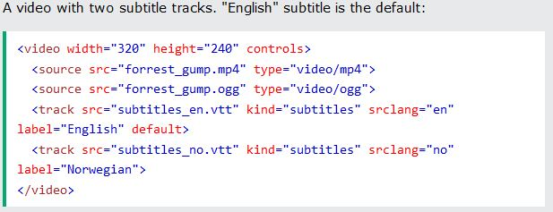

1. defer

* a Boolean attribute.
* tell the user agent to defer the execution of a script (external)
* supports script element.

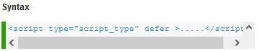

1. dir

* specifies the text direction of the element's content.
* global attribute.
* values are ltr (left to right) or rtl (right to left).

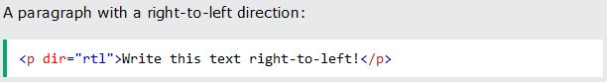

1. dirname

* enables the submission of the text direction of the input field/textarea.
* value is always the name of the input field/textarea, followed by ".dir".
* supports input and textarea elements.

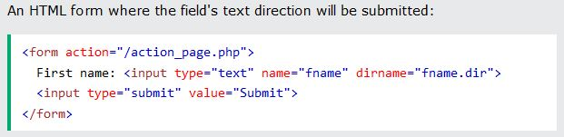

1. disabled

* a Boolean attribute.
* specifies that the element should be disabled.
* can be set to keep a user from using the element until some other condition has been met (like selecting a checkbox, etc.). Then, a JavaScript could remove the disabled value, and make the element usable again.
* supports button, fieldset, input, optgroup, option, select, textarea elements.
* no value needed.

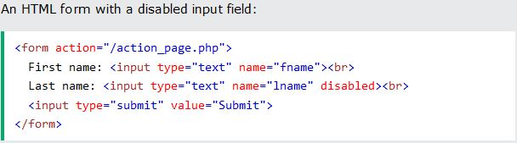

1. download

* specifies that the target will be downloaded when a user clicks on the hyperlink.
* only used if the href attribute is set.
* The value of the download attribute will be the new name of the downloaded file. There are no restrictions on allowed values, and the browser will automatically detect the correct file extension and add it to the file (.img, .pdf, .txt, .html, etc.).
* If the value is omitted, the original filename is used.
* supports a and area elements.

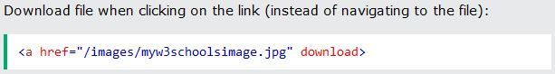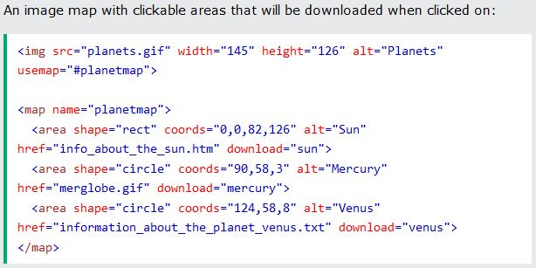

1. draggable

* specifies whether an element is draggable or not.
* Links and images are draggable by default.
* a global attribute.
* value set to “true”.

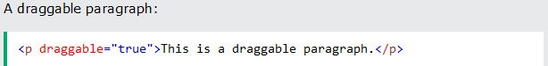

1. dropzone

* specifies whether the dragged data is copied, moved, or linked, when it is dropped on an element.
* a global attribute.
* not supported on browsers.

1. enctype

* specifies how the form-data should be encoded when submitting it to the server.
* can be used only if method="post".
* supports form element.

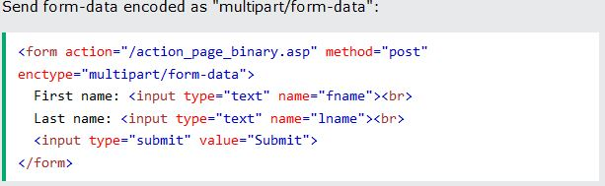

1. for

* supports label, output elements.
* to specify an identifier to a label element.
* When used together with the <label> element, the for attribute specifies which form element a label is bound to.
* When used together with the <output> element, the for attribute specifies the relationship between the result of the calculation, and the elements used in the calculation.

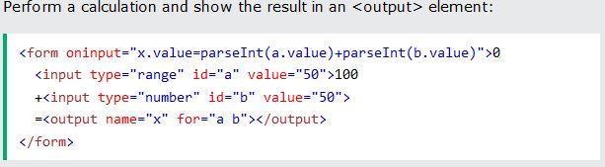

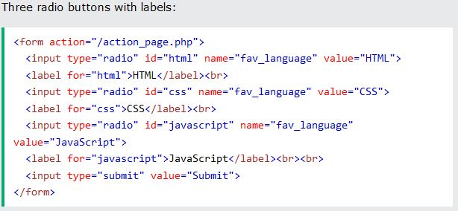

1. form

* specifies the form the element belongs to.
* value of this attribute must be equal to the id attribute of a <form> element in the same document.
* supports button, fieldset, input, label, meter, object, output, select, textarea elements.

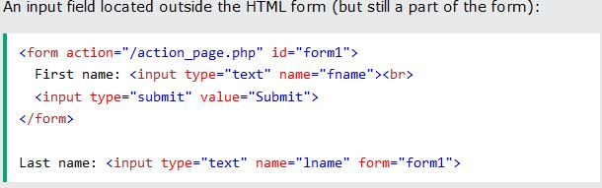

1. formaction

* specifies where to send the form-data when a form is submitted. This attribute overrides the form's action attribute.
* only used for inputs/buttons with type="submit".
* supports button and input element.

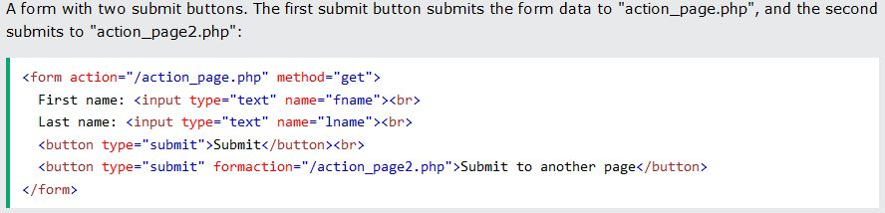

1. headers

* specifies one or more header cells a table cell is related to.
* supports td and th elements.

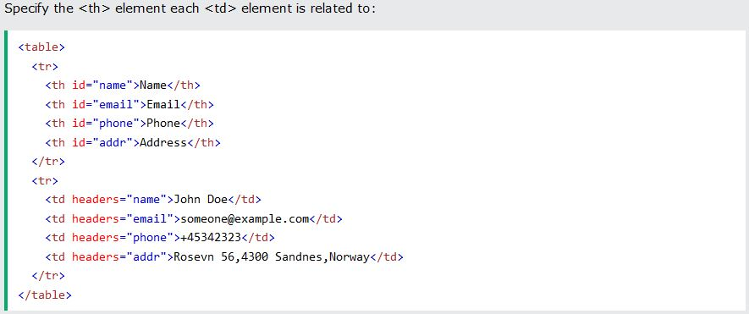

1. height

* specifies the height of an element in pixels.
* supports canvas, embed, iframe, img, input, object, video elements.



1. hidden

* a Boolean attribute.
* specifies that an element is not yet, or is no longer, relevant.
* can also be used to keep a user from seeing an element until some other condition has been met (like selecting a checkbox, etc.). Then, a JavaScript could remove the hidden attribute, and make the element visible.
* global attribute.
* no value needed.

1. high

* specifies the range where the gauge's value is considered to be a high value.
* value must be less than the max attribute value, and it also must be greater than the low and min attribute values.
* supports meter element.



1. href

* specifies the URL for any kind of link or image map.
* supports a, area, base, link elements.
* For <a> and <area> elements, the href attribute specifies the URL of the page the link goes to.
* For <base> elements, the href attribute specifies the base URL for all relative URLs on a page.
* For <link> elements, the href attribute specifies the location (URL) of the external resource (most often a style sheet file).

1. hreflang

* specifies the language of the linked document.

1. http-equiv

* provides an HTTP header for the information/value of the content attribute.
* can be used to simulate an HTTP response header.
* supports meta element.

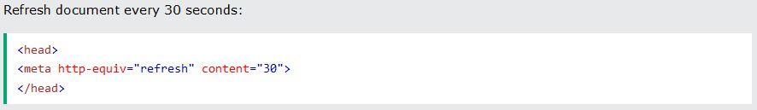

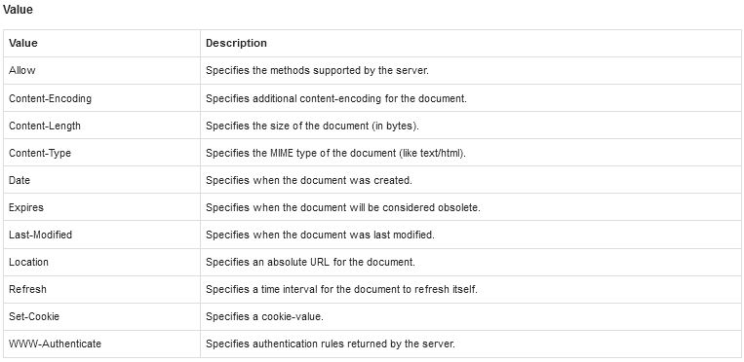

1. id

* specifies a unique id for an HTML element (the value must be unique within the HTML document).
* most used to point to a style in a style sheet, and by JavaScript (via the HTML DOM) to manipulate the element with the specific id.
* Global attribute.

1. ismap

* a Boolean attribute.
* specifies that the image is part of a server-side image map (an image map is an image with clickable areas).
* When clicking on a server-side image map, the click coordinates are sent to the server as a URL query string.
* supports img element.
* no value needed.

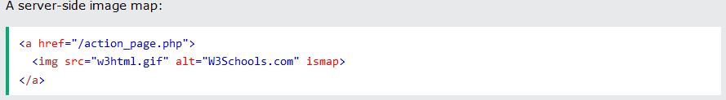

1. kind

* specifies the kind of text track.
* supports track element.

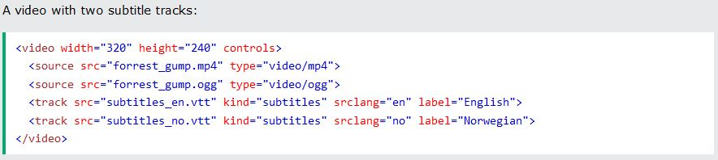

1. label

* specifies the title of the text track.
* supports track element.

1. lang

* specifies the language of the element's content.
* global attribute.



1. list

* refers to a <datalist> element that contains pre-defined options for an <input> element.
* supports input element.

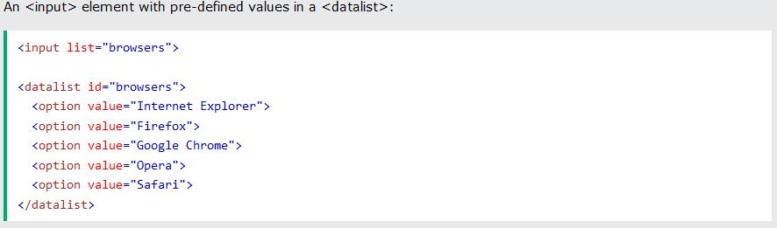

1. loop

* specifies that the audio/video will start over again, every time it is finished.
* supports audio/video elements.

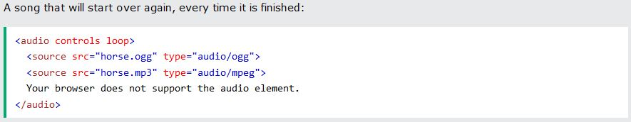

1. low

* specifies the range where the gauge's value is considered to be a low value.
* value must be greater than the min attribute value, and it also must be less than the high and max attribute values.
* supports meter element.



1. max

* specifies the maximum value of the element.
* supports input, meter, progress elements.

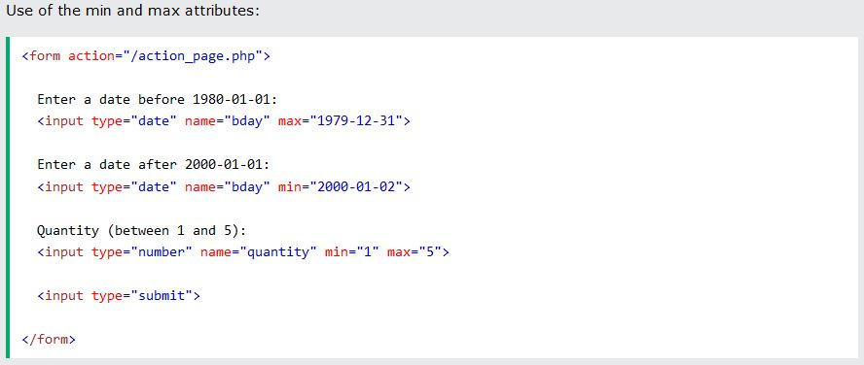

1. maxlength

* specifies the maximum number of characters allowed in the element.
* supports input and textarea elements.

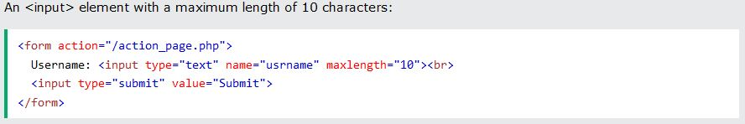

1. media

* specifies what media/device the linked document is optimized for.
* supports a, area, link, source, style elements.

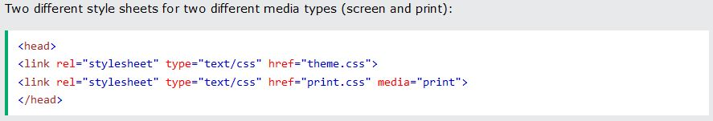

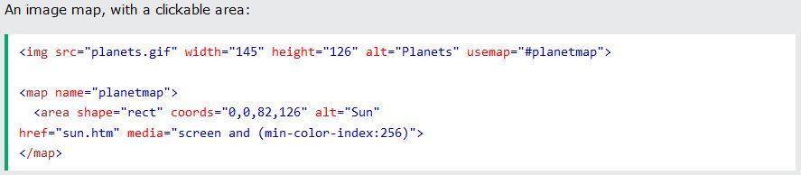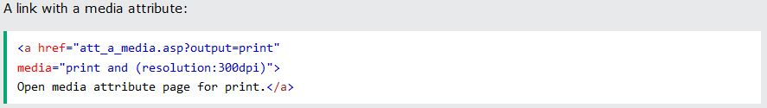

1. method

* Specifies the HTTP method to use when sending form-data.
* The form-data can be sent as URL variables (with method="get") or as HTTP post transaction (with method="post").
* **Notes on GET:**
  + Appends form-data into the URL in name/value pairs
  + The length of a URL is limited (about 3000 characters)
  + Never use GET to send sensitive data! (will be visible in the URL)
  + Useful for form submissions where a user want to bookmark the result
  + GET is better for non-secure data, like query strings in Google
* **Notes on POST:**
  + Appends form-data inside the body of the HTTP request (data is not shown is in URL)
  + Has no size limitations
  + Form submissions with POST cannot be bookmarked

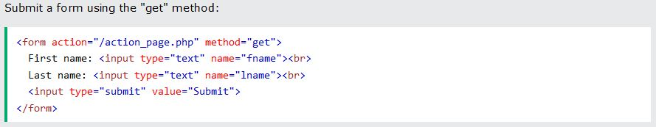

1. min